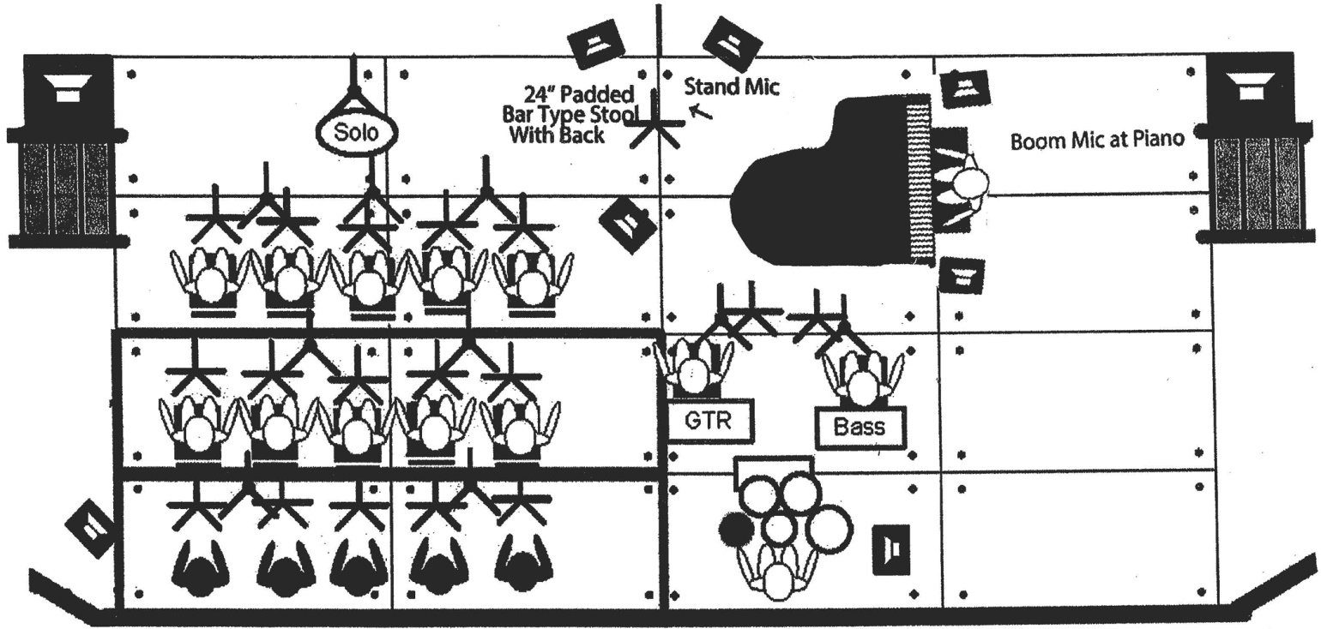

Diane Schuur

Piano Equipment needed:

YAMAHA 6’ Baby Grand Piano or 9’ Steinway Concert Grand Piano (Check on substitutions)
With adjustable concert piano bench.

Also: 24” PADDED BAR-TYPE STOOL WITH BACK, Plus Adjustable Vocal Microphone Stand

Sound & Stage Equipment needed:

Main House Speakers & Mixing Board w/ on stage mix & operator

(4) Monitor speakers; two at stand mic, two at piano. (Reverb in Ms. Schuur’s Vocal Mixes)
Piano should be miked on short stick or closed w/PCM

(2) DPA d:Facto Vocal Mic (1st choice), or Shure beta 87 Vocal Mic
(One stand out front, one boom at piano)

(1) 24 inch padded bar type stool with back at the stand mic.

PLEASE NOTE: The above list is for Diane only. All other musicians, including drummer and bass, will have their own requirements for sound & stage equipment, and input list should be adjusted accordingly.

Diane Schuur With Big Band
Input List

1. | KIK | COMP | SM-91 or B-52 | SHORT BM
2. | SNARE | COMP | SM-57 | SHORT BM
3. | HAT |  | SM-81 or 451 | SHORT BM
4. | RACK | GATE | AKG 408 or 98 | BM / CLIP
5. | FLOOR 1 | GATE | AKG 408 or 98 | BM / CLIP
6. | FLOOR 2 | GATE | AKG 408 or 98 | BM / CLIP
7. | OH SR |  | 414 or SM-81 | LG BOOM
8. | OH SL |  | 414 or SM-81 | LG BOOM
9. | BASS D.I. | COMP | D.I.
10. | PIANO |  | SM-91
11. | PIANO |  | SM-91
12. | PIANO |  | 414
13. | PIANO |  | 414
14. | SAX (Tenor) |  | SM-58 | BOOM
15. | SAX (Alto) |  | SM-58 | BOOM
16. | SAX (Alto) |  | SM-58 | BOOM
17. | SAX (Tenor) |  | SM-58 | BOOM
18. | SAX (Baritone) |  | SM-58 or RE-20 | BOOM
19. | BONE |  | SM-58 | SHORT BM
20. | BONE |  | SM-58 | SHORT BM
21. | BONE |  | SM-58 | SHORT BM
22. | TRUMPET |  | SM-57 | STRAIGHT
23. | TRUMPET |  | SM-57 | STRAIGHT
24. | TRUMPET |  | SM-57 | STRAIGHT
26. | VOC Diane | COMP | Beta 87 | STRAIGHT | Out Front
32.
33. | FX RET L | Reverb
34. | FX RET R | Reverb
35. | FX RET L | Reverb
36. | FX RET R | Reverb
39.

